Visual Representation of Data :

# 1. Plot of Annual Sales grouped by Month :

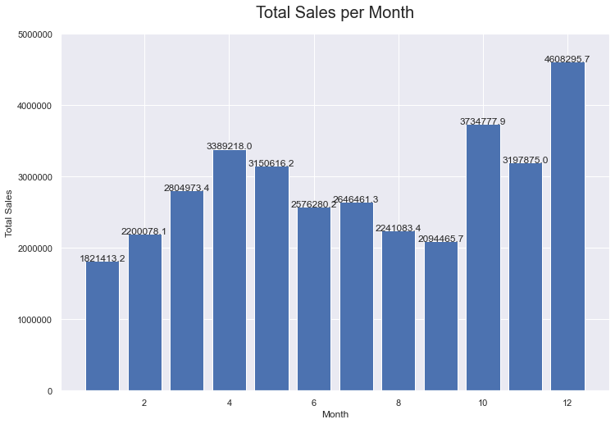

# 2. Plot of Annual Sales grouped by City :

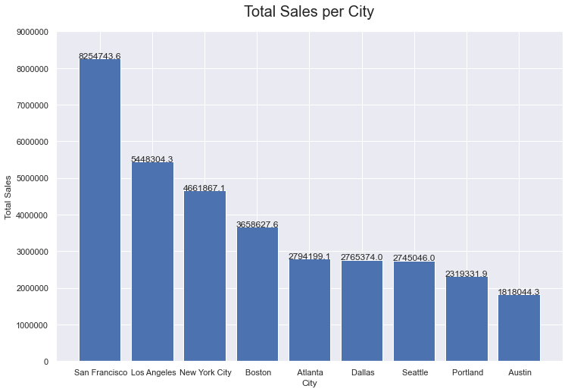

# 3. Plot of Sales Trend in Top 5 Cities :

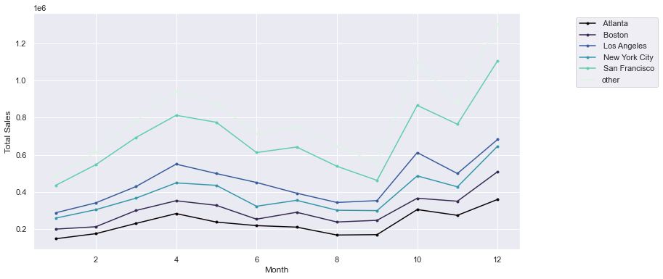

# 4. Plot of Daily Sales Trend grouped by Hour :

# graph 4.png

# 5. List of Items frequently bought together ordered by asc :

('iPhone', 'Lightning Charging Cable') 1002

('Google Phone', 'USB-C Charging Cable') 985

('iPhone', 'Wired Headphones') 447

('Google Phone', 'Wired Headphones') 413

('Vareebadd Phone', 'USB-C Charging Cable') 361

('iPhone', 'Apple Airpods Headphones') 360

('Google Phone', 'Bose SoundSport Headphones') 220

('USB-C Charging Cable', 'Wired Headphones') 159

('Vareebadd Phone', 'Wired Headphones') 143

('Lightning Charging Cable', 'Wired Headphones') 92

# 6. Plot of Most Popular Items :

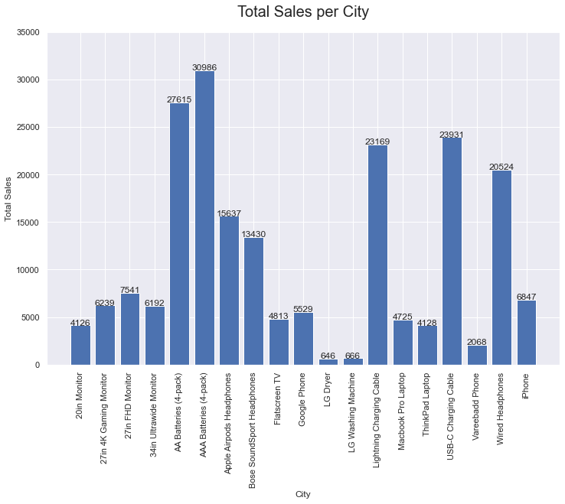

Key Insights

## Some of the findings after analyzing the data above are as follows:

1. The most sales occurred in December, while the lowest was in January. The earnings in December was $ 4608295.70
2. San Francisco was the city that had the highest total sales with 8,254,743 units. The lowest city was Austin with a total of 1,818,044 units.
3. There was a decrease in from April to September.
4. The right time to do advertising appears to be within the time frame of 10.00 am to 21.00 pm
5. Iphone was most often sold together with the Lightning Charge Cable.
6. AAA Batteries (4-packs) were the most sold products with 30986 units, While the least sold products were LG Dryer with just 646 units sold.

Conclusion

## We can advise company managers to:

1. Find out what happened to cause the dip in sales in April-September stretch. It could be caused by external factors such as certain events, pandemics, financial crises, etc. Meanwhile, internal conditions of cause may include limited stock of goods, quality of goods, loss/theft of goods, marketing activities, etc. Thus, the company can make sure that the following year will not experience a mid-year decline in sales.
2. Responding to the lowest sales in several cities, the company can carry out promotional strategies such as free shipping or adding cheaper shipping options.
3. Seeing that sales of mobile phones accompany with them the sale of corresponding accessories, companies can carry out marketing strategies by providing special prices for bundle purchase of the mobile phone and it’s accessories to boost sales.
4. For the fewest items sold, the company can carry out marketing strategies such as flash sales, discounts, price reductions, etc.